

The Two Years BEFORE Kindergarten
(Age 3 by Sept. 1)

Cubbies® celebrates the spiritual potential of preschoolers (3- to 5-year olds) by helping them develop respect for God, His Son and His Word.

Cubbies helps you lead your child to God early so she will respect and trust Him for life.

Children begin with an entrance booklet called Apple Acres. When they complete the brochure, then they are able to purchase their uniform vest and their handbook.

The AppleSeed and HoneyComb handbooks combine basic Scripture memory with parent-child activities to help Cubbies grasp simple biblical truths. One handbook is completed in a club year.

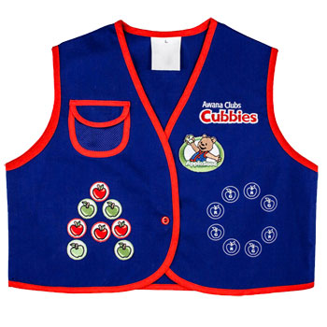



Kindergarten – 2nd Grade

Sparks® ignites the curiosity of early elementary-age kids to learn about the people and events of the Bible, building a foundation of wisdom for knowing Christ.

To many children in kindergarten to second grade, Sparks® is the highlight of the week! They love their red vests, the exciting games and spending time with leaders and friends.

Sparks is divided into three years, each with a unique rank:
- HangGlider®
- WingRunner®
- SkyStormer™

Each year, Sparks clubbers:
- explore the biographies of people of the Bible from a new portion of Scripture
- memorize Bible verses
- complete handbook activities
Children begin with an entrance booklet called Flight 3:16. When they complete Flight 3:16, then they are able to purchase their uniform vest and their first handbook


3rd – 6th Grade

Truth and Training™ is the Awana program for kids in 3rd - 6th grade. T&T™ focuses on the basics of the Christian faith and guides kids to a deeper understanding of God’s grace.

Each year of T&T contains lessons about God, the Bible, Jesus, Life Application, and corresponding memory verses.

T&T engages third through sixth graders, guiding them through this pivotal life stage to grow in Christ's grace.

T&T deepens a child's knowledge about God and His Word, teaching them how to put that knowledge into action in everyday life.

All 3rd - 6th graders begin with a Start Zone booklet that introduces the gospel and basic Bible concepts.
All T&T kids complete the Start Zone before entering the handbook each year. All 3rd – 6th graders work together through same book during the Awana year



Awana is a nondenominational ministry that assists churches in reaching children and teenagers with the gospel of Jesus Christ and training them to serve Him. Awana supplies programs, materials and training for more than 12,000 churches in over 110 countries. Their message to churches is simple: We're here to serve you with a ministry that is all about fun with a purpose — to win and grow kids for Christ!

That’s why Awana offers a series of clubs and programs geared to the needs of a particular age or grade. As a vital part of our local church ministry, Awana clubs and programs effectively reach young people with the good news of Jesus Christ.

Here at Hanover Fellowship, our Awana ministry works with other ministries to give our children and youth a well-balanced emphasis on knowing Jesus and how we can live for Him and serve Him. We also strive to work with families as they raise their children to know and serve Jesus.

This brochure is designed to give you a general overview of Awana. If you have any questions, please feel free to contact us with the information on the back panel.

Thank you for your interest in the Awana ministry.



Bill Gunter
Awana Ministry Director
e-mail: children.hanoverfellowship@gmail.com

Awana meets Wednesday nights
(Sept. - May)
From 6:30 pm – 8:00 pm



Hanover Fellowship Church
200 South Street
Hanover, PA 17331
717.637.5230
www.hanoverfellowship.org

Meeting Sunday Mornings at 10:00 am
Pastor John Harling

