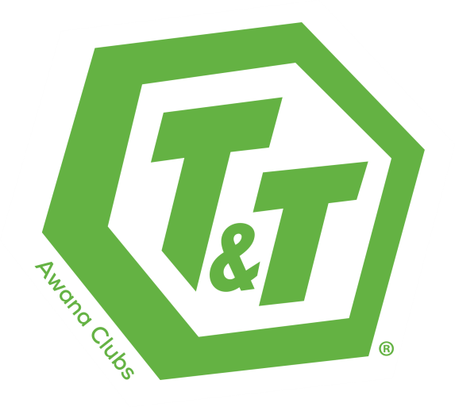

An exciting club for
3rd-4th graders (Truth) and 5th-6th graders (Training)!
2 Clubs in 1 so each age group learns at their level.

T&T is accessible for kids from every background. Fun activities to help
enrich their understanding of what they are learning and memorizing.
We provide deeper discipleship through bonds with their friends,
prayer, and guidance from adults who genuinely care.

Small Groups for a deeper understanding
Bible Studies for growth in their life journey
Focused storyline and structure

The total cost for the year is $39.00 or $55.00 w/ uniform

