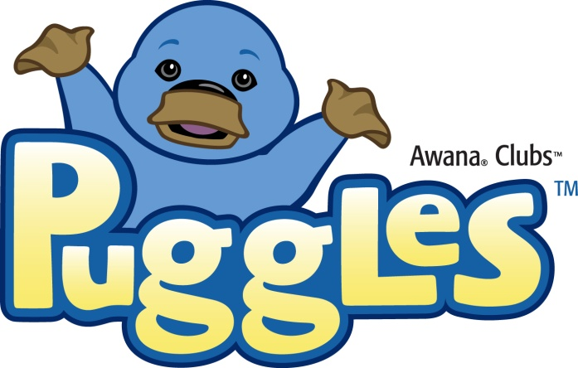

Puggles® recognizes the learning ability of 2 year olds! In Puggles, our 2 year olds are welcomed each week with play time, songs and simple crafts and activities. Leaders present age-appropriate lessons using large, colorful teaching cards, finger puppet plays and more.

Lessons teach and reinforce four basic biblical precepts:
God Made Everything
God Saw That It Was Good
God is Love
Give Thanks

Special take-home cards that correspond to each week's lesson help parents nurture their child's faith at home. Participating in Puggles will give your child a head start on the path to loving and following God for life.
The total cost for the year is $11

